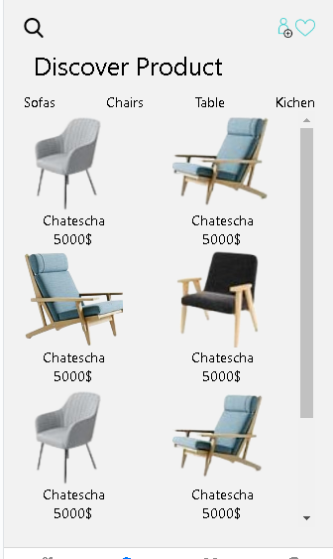

import React, { useEffect } from 'react';

import { View, Text, Button, FlatList, ActivityIndicator, StyleSheet, Image }

import { useDispatch, useSelector } from 'react-redux';

from 'react-native';

import { fetchItems } from '../reduxToolkit/store'

const Item = ({id, title, price}) => (

  <View style = {{display : "flex", justifyContent : 'space-around', marginRight :50, alignItems: 'center'}}>

      <Image resizeMode = 'cover' style = {{width : 100, height : 100}} source = {id}/>

      <Text >{title}</Text>

      <Text >{price}</Text>

  </View>

  )

const Product = ({ navigation }) => {

 const dispatch = useDispatch();

  const { items, loading, error } = useSelector(state => state.test);

  useEffect(() => {

    dispatch(fetchItems());

  }, [dispatch]);

  return (

    <View style={styles.container}>

      <View style ={{flexDirection : 'row', gap : 10, justifyContent : 'space-between'}}>

          <Image resizeMode = 'cover' style = {{width : 20, height : 20}} source = {require('../assets/search.png')} />

          <View style = {{flexDirection : 'row'}}>

          <Image resizeMode = 'cover' style = {{width : 20, height : 20}} source = {require('../assets/profile.png')} />

          <Image resizeMode = 'cover' style = {{width : 20, height : 20}} source = {require('../assets/heart.png')} />

          </View>

      </View>

      <Text style ={{margin : 10, fontSize :25}}>Discover Product</Text>

      <View style ={{flexDirection : 'row', gap : 10, justifyContent : 'space-between'}}>

        <Text>Sofas</Text>

        <Text>Chairs</Text>

        <Text>Table</Text>

        <Text>Kichen</Text>

      </View>

      <FlatList

        data={DATA}

        numColumns = {2}

        renderItem={({item}) => <Item id={item.id} title = {item.title} price = {item.price}/>}

        keyExtractor={item => item.id}

      />

    </View>

  );

};

  const styles = StyleSheet.create({

    container: { flex: 1, padding: 20 },

  });

export default Product;